Project Design Phase
Solution Architecture

Date | 10 February 2026
Team ID | LTVIP2026TMIDS87433
Project Name | Rain Prediction Pipeline Flask
Maximum Marks | 4 Marks

Solution Architecture:
The solution architecture defines how the Rain Prediction Pipeline bridges user requirements with technical implementation.
It describes the overall structure of the Flask-based web application integrated with a machine learning model for rainfall prediction.
The architecture outlines data flow from user input through preprocessing and prediction to result display, ensuring clarity in system behavior, development phases, and deployment strategy. It also specifies the components required to deliver accurate predictions while maintaining scalability and usability.
Example - Solution Architecture Diagram:

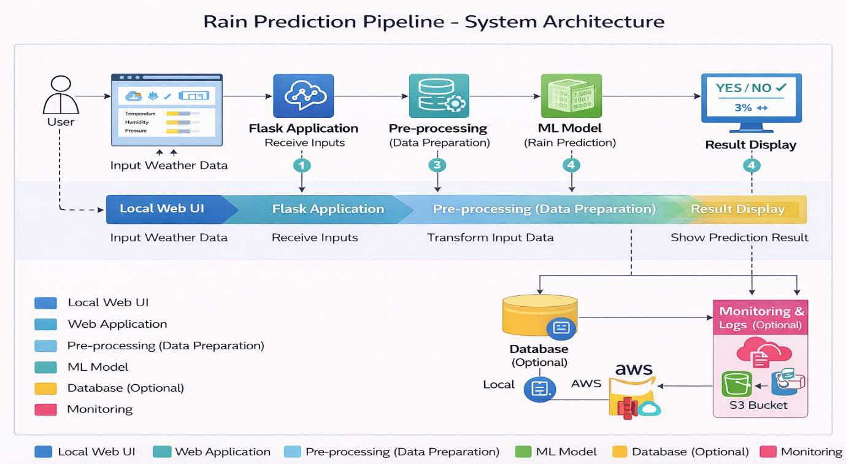
Figure 1: Architecture and data flow of the Rainfall Prediction Pipeline

